Assignment 4 LCD Interface

Released Date: Oct 31th

Version 1.0

Format: Name the document in the combination of name、ID and No. of Assignment.

**Example: Ping Yi_23_Assignment1.doc**

**Email the document to “pingy@wxit.edu.cn” before Nov 6th.**

**Task 1** 4 LEDs are connected to Arduino Uno, try to use LCD1602 to display the current state of LED been lighted.

任务1 使用3个LED连接至Arduino Uno，使用LCD1602 显示当前小灯点亮的状态，（1s位移）。

**You could use Tinker CAD or Proteus for the verifying.可使用在线工具Tinker CAD或Proteus进行仿真。**



**Fig 1 LCD Display Indicator**

**Answer:**

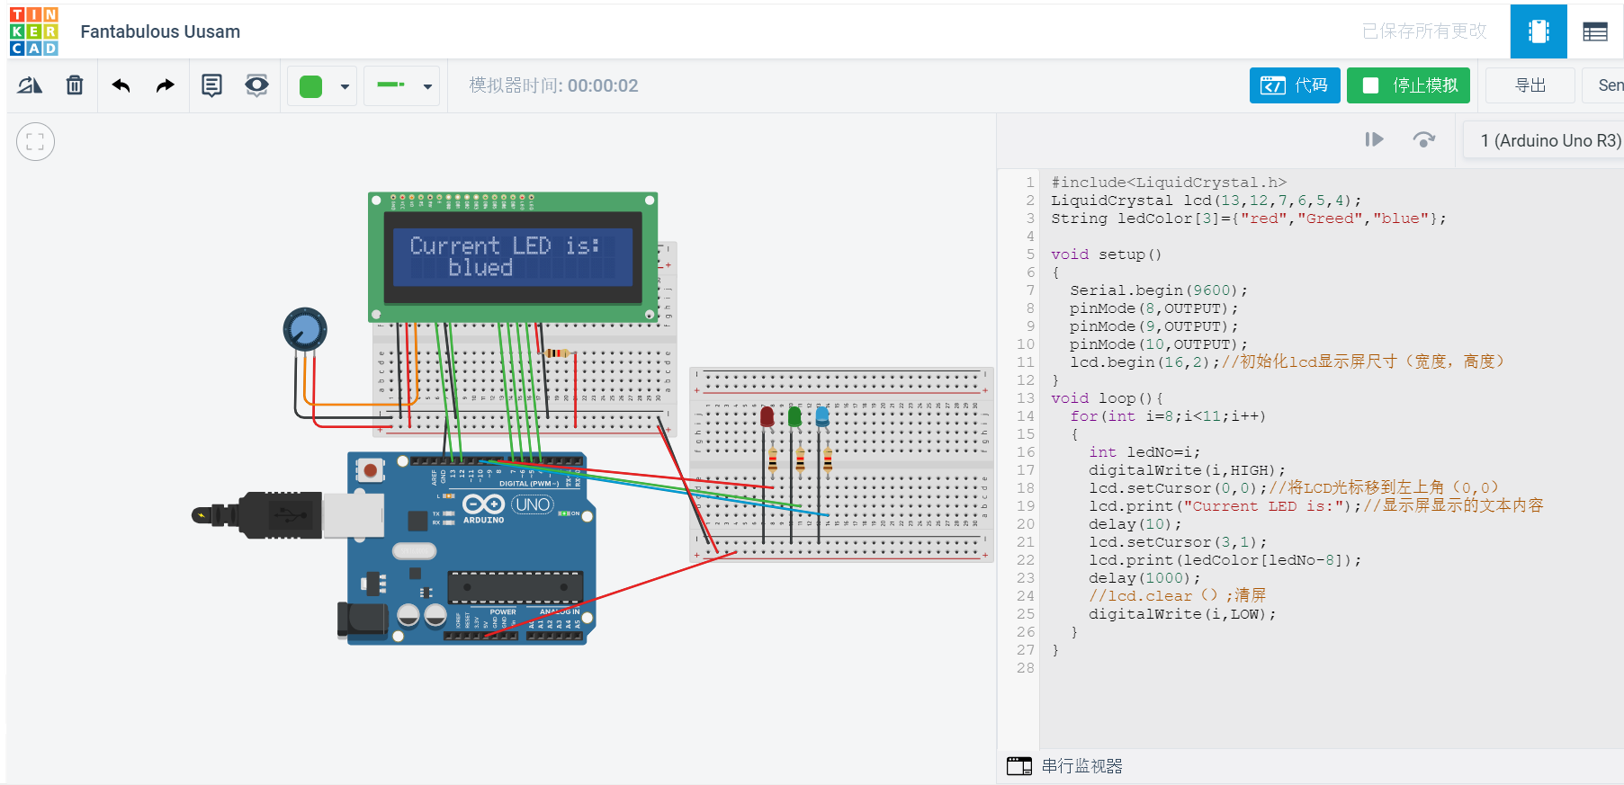

1. #include<LiquidCrystal.h>
2. LiquidCrystal lcd(13,12,7,6,5,4);
3. String ledColor[3]={"red","Greed","blue"};
5. **void** setup()
6. {
7. Serial.begin(9600);
8. pinMode(8,OUTPUT);
9. pinMode(9,OUTPUT);
10. pinMode(10,OUTPUT);
11. lcd.begin(16,2);//初始化lcd显示屏尺寸（宽度，高度）
12. }
13. **void** loop(){
14. **for**(**int** i=8;i<11;i++)
15. {
16. **int** ledNo=i;
17. digitalWrite(i,HIGH);
18. lcd.setCursor(0,0);//将LCD光标移到左上角（0,0）
19. lcd.print("Current LED is:");//显示屏显示的文本内容
20. delay(10);
21. lcd.setCursor(3,1);
22. lcd.print(ledColor[ledNo-8]);
23. delay(1000);
24. //lcd.clear（）;清屏
25. digitalWrite(i,LOW);
26. }
27. }